Digital-Nurture-5.0-Deep-Skilling-Java-hands-on-exercise WEEK 1

Exercise 1: Mocking and Stubbing Scenario: You need to test a service that depends on an external API.
Use Mockito to mock the external API and stub its methods.
Steps: 1. Create a mock object for the external API.
2. Stub the methods to return predefined values.
3. Write a test case that uses the mock object.
Solution Code:
import static org.mockito.Mockito.*;
import org.junit.jupiter.api.Test;
import org.mockito.Mockito;
public class MyServiceTest { @Test public void testExternalApi() {
ExternalApi mockApi = Mockito.mock(ExternalApi.class);
when(mockApi.getData())
.thenReturn("Mock Data");
MyService service = new MyService(mockApi);
String result = service.fetchData();
assertEquals("Mock Data", result);
}
}

OUTPUT :
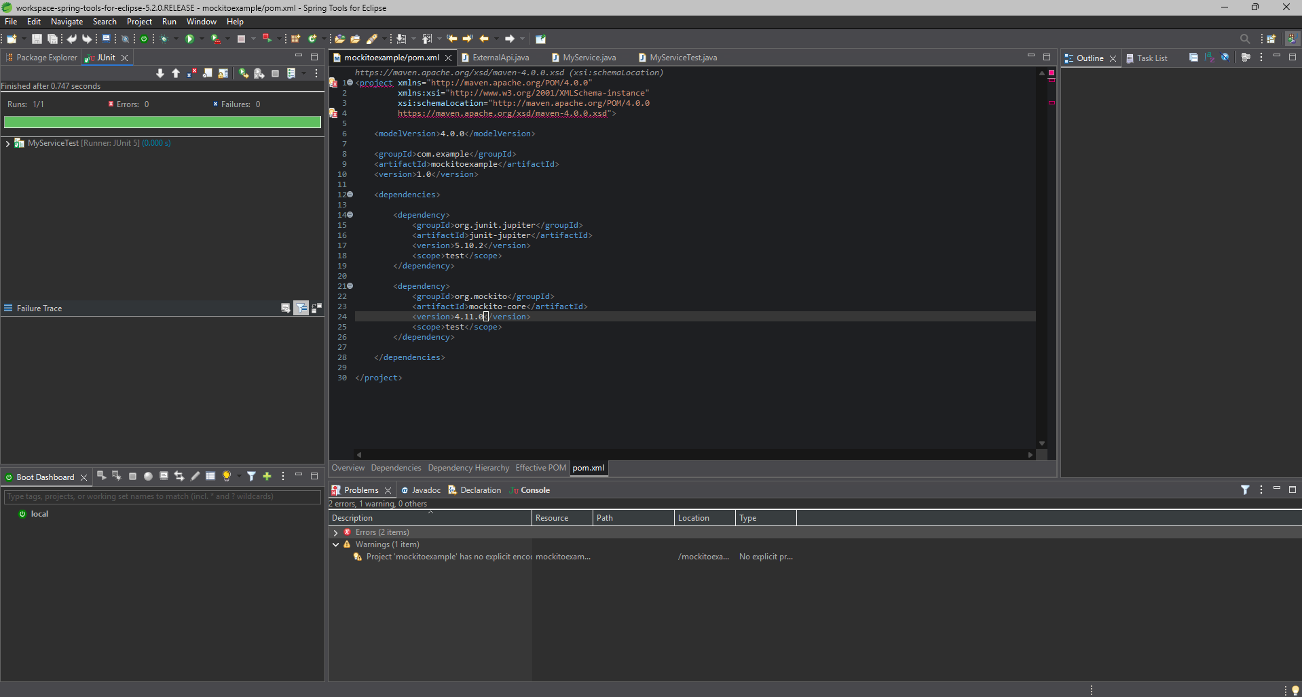

Exercise 2: Verifying Interactions Scenario:
You need to ensure that a method is called with specific arguments.
Steps:
1. Create a mock object.
2. Call the method with specific arguments.
3. Verify the interaction.
Solution Code:
import static org.mockito.Mockito.*;
import org.junit.jupiter.api.Test;
import org.mockito.Mockito;
public class MyServiceTest { @Test public void testVerifyInteraction() {
ExternalApi mockApi = Mockito.mock(ExternalApi.class);
MyService service = new MyService(mockApi);
service.fetchData();
verify(mockApi).getData();
}
}

OUTPUT :
